# 1. Blinky Sample

We’ll create a simple LED blinking app and connect a LED to your Windows 10 IoT Core device.

This is a headed sample. To better understand what headed mode is go [here](http://ms-iot.github.io/content/en-US/win10/HeadlessMode.htm).

Also, be aware that the GPIO APIs are only available on Windows 10 IoT Core, so this sample cannot run on your desktop.

**1.2 Load the Project in Visual Studio**

You can find the source code for this sample by navigating to the IoT Track folder content and 1.BlinkyandtheCloud -> samples-develop\samples-develop\Blinky. The sample code is available in either C++ or C#; however, the documentation here only details the C# variant. Make a copy of the folder on your disk and open the project from Visual Studio.

**1.3 Connect the LED to your Windows IoT device**

You’ll need a few components:

* a LED (whichever colour you like)
* a 220 Ω resistor
* a breadboard and a couple of connector wires

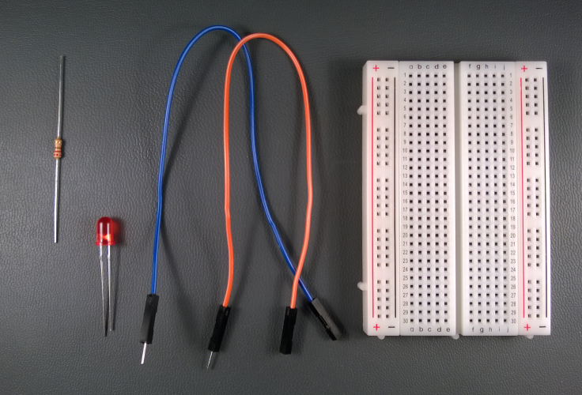

**1.4 For Raspberry Pi 2 (RPi2)**

We will connect the one end of the LED to GPIO 5 (pin 29 on the expansion header) on the RPi2, the other end to the resistor, and the resistor to the 3.3 volt power supply from the RPi2. Note that the polarity of the LED is important. Make sure the shorter leg (-) is connected to GPIO 5 and the longer leg (+) to the resistor or it won’t light up.

And here is the pinout of the RPi2:

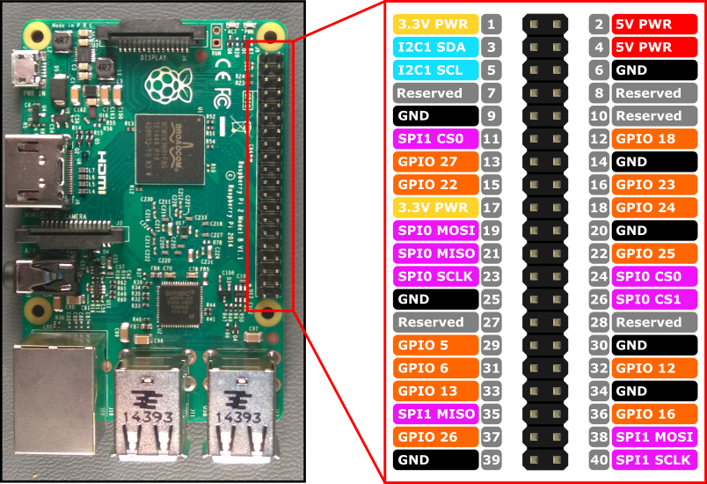

Image made with [*Fritzing*](http://fritzing.org/)

Here is an example of what your breadboard might look like with the circuit assembled:

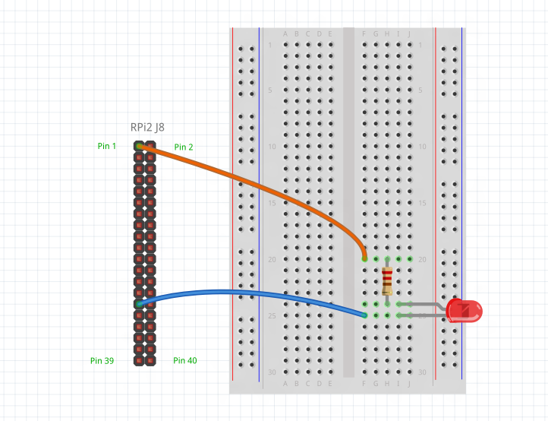

Image made with [*Fritzing*](http://fritzing.org/)

**1.5 Deploy your app**

1. With the application open in Visual Studio, set the architecture in the toolbar dropdown. You’re building for Raspberry Pi 2, so select ARM.
2. Next, in the Visual Studio toolbar, click on the Local Machine dropdown and select Remote Machine

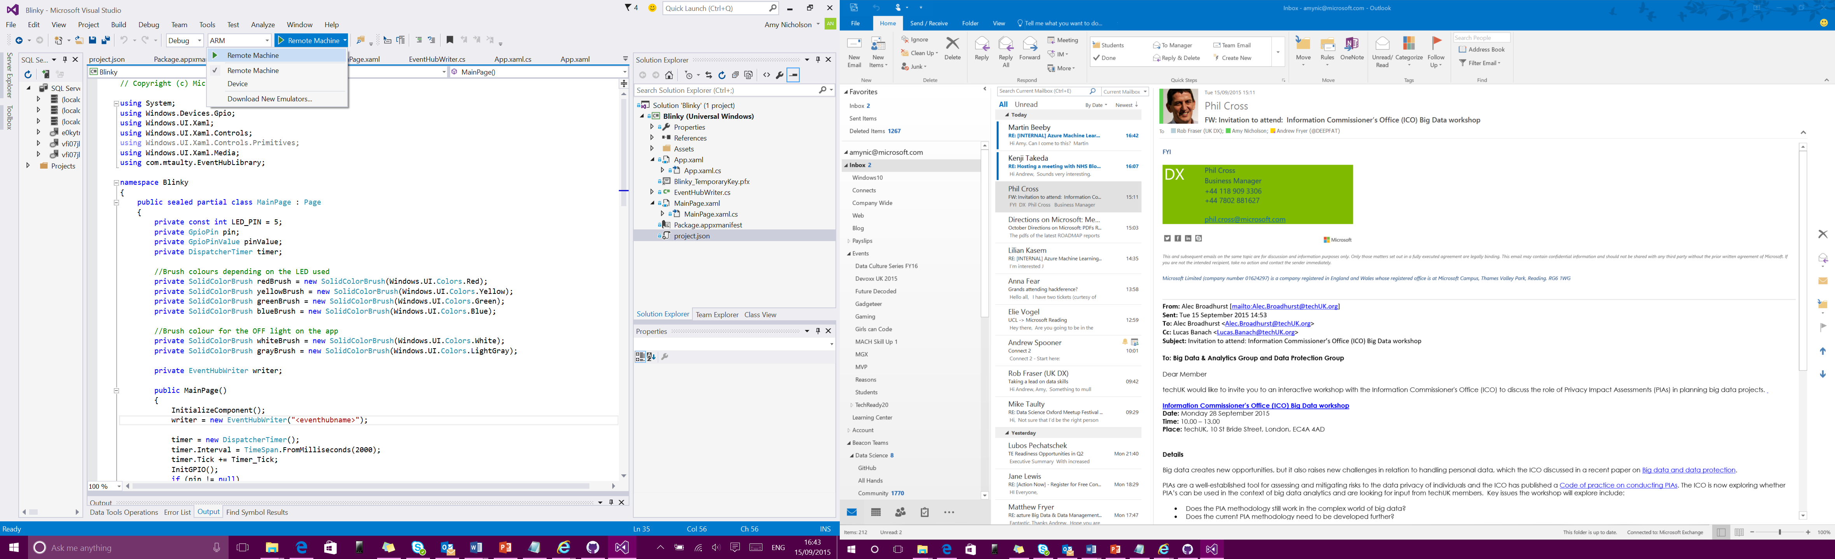

1. At this point, Visual Studio will present the **Remote Connections** dialog. If your device has a unique name (see IoT Core Watcher), you can enter it here (in this example, we’re using **my-device**). Otherwise, use the IP address of your Windows IoT Core device. After entering the device name/IP select None for Windows Authentication, then click **Select**.

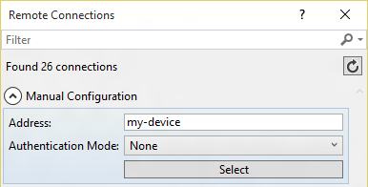

1. You can verify or modify these values by navigating to the project properties (select **Properties** in the Solution Explorer) and choosing the Debug tab on the left:

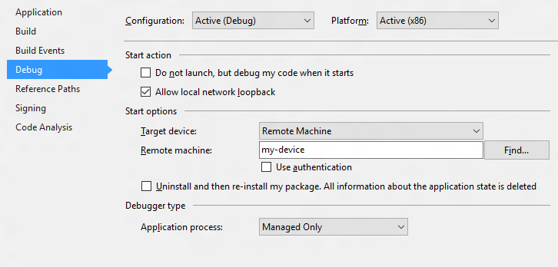

When everything is set up, you should be able to press F5 from Visual Studio. The Blinky app will deploy and start on the Windows IoT device, if you have a screen you should see the LED blink in sync with the simulation on the screen.



Congratulations! You controlled one of the GPIO pins on your Windows IoT device.

**1.6 Let’s look at the code**

The code for this sample is pretty simple. We use a timer, and each time the ‘Tick’ event is called, we flip the state of the LED.

1.6.1 Let’s look at the code

Here is how you set up the timer in C#:

public MainPage()

{

// ...

this.timer = new DispatcherTimer();

this.timer.Interval = TimeSpan.FromMilliseconds(500);

this.timer.Tick += Timer_Tick;

this.timer.Start();

// ...

}

private void Timer_Tick(object sender, object e)

{

FlipLED();

}

1.6.2 Initialise the GPIO pin

To drive the GPIO pin, first we need to initialize it. Here is the C# code (notice how we leverage the new WinRT classes in the Windows.Devices.Gpio namespace):

using Windows.Devices.Gpio;

private void InitGPIO()

{

var gpio = GpioController.GetDefault();

// Show an error if there is no GPIO controller

if (gpio == null)

{

pin = null;

GpioStatus.Text = "There is no GPIO controller on this device.";

return;

}

pin = gpio.OpenPin(LED_PIN);

// Show an error if the pin wasn't initialized properly

if (pin == null)

{

GpioStatus.Text = "There were problems initializing the GPIO pin.";

return;

}

pin.Write(GpioPinValue.High);

pin.SetDriveMode(GpioPinDriveMode.Output);

GpioStatus.Text = "GPIO pin initialized correctly.";

}

Let’s break this down a little:

* First, we use GpioController.GetDefault() to get the GPIO controller.
* If the device does not have a GPIO controller, this function will return null.
* Then we attempt to open the pin by calling GpioController.OpenPin() with the LED_PIN value.
* Once we have the pin, we set it to be off (High) by default using the GpioPin.Write() function.
* We also set the pin to run in output mode using the GpioPin.SetDriveMode() function.

1.6.3 Modify the state of the GPIO pin

Once we have access to the GpioOutputPin instance, it’s trivial to change the state of the pin to turn the LED on or off.

To turn the LED on, simply write the value GpioPinValue.Low to the pin:

this.pin.Write(GpioPinValue.Low);

and of course, write GpioPinValue.High to turn the LED off:

this.pin.Write(GpioPinValue.High);

Remember that we connected the other end of the LED to the 3.3 Volts power supply, so we need to drive the pin to low to have current flow into the LED.